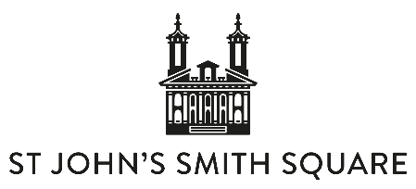

SOUTHBANK SINFONIA
2023 BIOGRAPHY
Each year, Southbank Sinfonia welcomes 33 of the world’s most promising emerging musicians to embark on its renowned Fellowship. The orchestra was founded in 2002 by Music Director Simon Over to provide graduate musicians with a much-needed springboard into the profession.
More than just an orchestra, this is a community where young talents can find their own creative strengths, fulfil personal goals, make lasting contacts, and take their musicianship to new frontiers. Alongside unparalleled opportunities to gain crucial experience in orchestral repertoire, chamber music, opera, dance and theatre, Southbank Sinfonia celebrates how intrepid young players can have a uniquely important voice in the sector, shaping the future of their artform. Whether in Rush Hour Concerts, the hit production of Amadeus at the National Theatre, or through collaborations with the Royal Opera House, Sadler’s Wells or trailblazing guest artists, Southbank Sinfonia’s musicians bring fresh resonance to the stage. To date, over 600 musicians have completed the programme and can be found worldwide in leading orchestras and acclaimed chamber ensembles, as inspiring music educators, and pioneering their own entrepreneurial musical ventures.
Most recently, the orchestra has merged with world renowned venue St John’s Smith Square. As one new charity, Southbank Sinfonia at St John’s Smith Square creates a hub for world-class musical development, placing emerging talent at the heart of the organisation. It offers a permanent home for a renowned orchestral Fellowship programme and acts as a beacon for the future of classical music, embracing versatility and innovation in everything from great symphonies to bold new musical adventures.

